

Course: Robotics Systems
RSE1201 - C Programming [2024/25 T1]

Group Project - Milestone 1

Project Members:

Student Name | Student ID
Tan Yong Jie | 2400994
Amos Teo | 2400571
Lwin Moe Aung | 2400594
Leon Chia | 2401047
Aloysius | 2401686
Beckham | 2400867
James | 2403139
Kim | 2403290

Date of Submission : 20 November 2024
Table of Contents

1.0 Architecture Overview 3
2.0 System Design 6
2.1 Overview 6
2.1.1 Overview (Flowchart) 6
2.1.1 Global Variable(Code) 6
2.2 Pre-Game 7
2.2.1 Pre-Game (Flowchart) 7
2.2.2 Pre-Game (Code) 8
2.3 Game 11
2.3.1 Game (FlowChart) 11
2.3.2 Game (Code) 12
2.4 Post Game 21
2.4.1 Post Game (Flow Chart) 21
2.4.2 Post Game (Code) 22
3.0 Testing and Discovery 25
3.1 Terrain symbols 25
3.2 Energy and shield energy when moving 25
3.3 Scan energy expenditure 25
4.0 Reflections on program development 26
4.1 Work breakdown 26
4.2 Obstacle encountered 26
5.0 Extra functionalities 27

1.0 Architecture Overview

Linking header file to source code
To link the header file SatComRelay.h, in the main code, you need to use #include file name. “../inc/” string is to change file directory to inc and search for SatComRelay.h.

Header File
Source File
include "../inc/SatComRelay.h"

Linking Struct
To access all the data in VehDatType in header file, in source code below, My_vehicle pull out data from VehDataType.

Header File
typedef struct VehData VehDataType;
Source File
VehDataType My_vehicle;

Sending data to Signal Veh Init
To send data to the header file “SCRelay_Signal_Veh_init”, in the source code below, the variable sent out to the header file must link. The first variable required is char, followed by bool, bool, and lastly int.

Header File
VehDataType SCRelay_Signal_Veh_Init (char * srcFilename, bool fileNeedsDecryption, bool randomizeStartPosition, int missionType);
Source File
My_vehicle SCRelay_Signal_Veh_Init(filename,&scr_name_bl,&random_start_pos_bl,mission);

Reading data from VehData
To read a data file from struct VehData. In the source file below, for example, you need to read the long initialEnergy from the header file; in the source file to take the data, it needs My_vehicle.initialEnergy.

Header File
struct VehData{long initialEnergy; long currEnergy, currShieldEnergy; long totEnergyUsed, totShieldEnergyUsed;};
Source File
printf("Initial Enrg : %1ld, Tot Enrg Use : %1ld, Tot Shld Enrg Use : % 1ld, Engy Left : %1ld, Shld Enrg Left : %1ld \n\n", My_vehicle.initialEnergy, My_vehicle.totEnergyUsed, My_vehicle.totShieldEnergyUsed, My_vehicle.currEnergy, My_vehicle.currShieldEnergy);

Allocate energy to shield
To send data to the header file SCRelay_Signal_Veh_AllocateToShield, in source code the variable needs to be the same long variable.

Header File
VehDataType SCRelay_Signal_Veh_AllocateToShield (long amountOfEnergy);
Source File
My_vehicle = SCRelay_Signal_Veh_AllocateToShield(energyToAllocate);

Vehicle Movement
To use the header file SC_Relay_Signal_Veh_MoveUpNorth(); , in the source file below, you just need to use the same function to call out.

Header File
VehDataType SCRelay_Signal_Veh_MoveUpNorth ();
Source File
SCRelay_Signal_Veh_ScanNorth(&My_vehicle);

Vehicle Scanning
To read data from SCRelay_Signal_VehScanNorth from the header file, which is source code, you need to declare a variable to store characters, as the header file uses characters to send out data.

Header File
char SCRelay_Signal_Veh_ScanNorth (VehDataType * vdt);
Source File
scanresult = SCRelay_Signal_Veh_ScanNorth (&My_vehicle);

2.0 System Design

2.1 Overview

2.1.1 Overview (Flowchart)
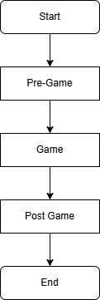

2.2 Pre-Game

2.2.1 Pre-Game (Flowchart)

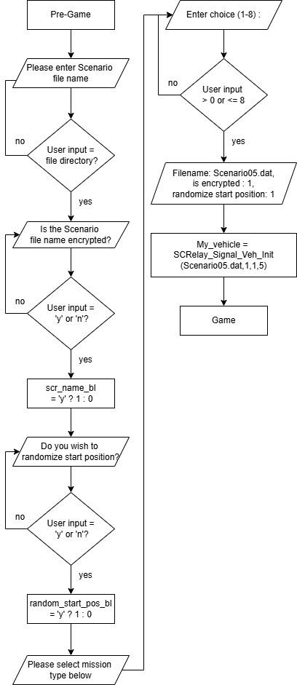

2.2.2 Pre-Game (Code)

Pre-Game
Declaring of variable | char filename[15], file_directory[30];  bool scr_name_bl, random_start_pos_bl;  int mission;
Description | Filename[15] is used as char name which provide string up to 14  File_directory[30] is used as char name which provide string up to 30  Boolean variable of scr_name_bl and random_start_pos_bl is used as value 1 or 0 according to user input.  Call mission as int
Main Function | do  {  printf("\nPlease enter the scenario file's name : ");  scanf("%s",filename);  while (getchar() != '\n');  snprintf(file_directory, sizeof(file_directory), "./%s", filename);  printf("Checking path: %s. \n", file_directory);  if(access(file_directory,F_OK) == -1)  {  printf("File does not exist. \n");  }  else  {  printf("File Exist. \n");  }  }while(access(file_directory,F_OK) == -1);  printf("\n");  do  {  printf("Is the scenario name encrypted (y/n): ");  char_checker();  if(Error == 1 || (user_input_c != 'y' && user_input_c != 'n'))  {  printf("Invalid character. Please enter 'y' or 'n'.\n");  }  else  {  scr_name_bl = user_input_c == 'y'? 1 : 0;  }  printf("\n");  }  while(Error == 1 || (user_input_c != 'y' && user_input_c != 'n'));  do  {  printf("Do you wish to randomize start position (y/n): ");  char_checker();  if(Error == 1 || (user_input_c != 'y' && user_input_c != 'n'))  {  printf("Invalid character. Please enter 'y' or 'n'.\n");  }  else  {  random_start_pos_bl = user_input_c == 'y'? 1 : 0;  }  printf("\n");  }  while(Error == 1 || (user_input_c != 'y' && user_input_c != 'n'));  printf("Please select mission type below\n\n");  printf(" 1) Casual Explore\n");  printf(" 2) Find 1 End Point\n");  printf(" 3) Reach 1 End Point \n");  printf(" 4) Find ALL End Point \n");  printf(" 5) Reach ALL End Point \n");  printf(" 6) Reach ALL Danger Point \n");  printf(" 7) Find Map Boundaries \n");  printf(" 8) Explore Everything \n\n");  do  {  printf("Enter your choice (1-8) : ");  int_checker();  if(Error == 1 || user_input <= 0 || user_input > 8 )  {  printf("Please enter 1 - 8. \n\n");  }  }  while(Error == 1 || user_input <= 0 || user_input > 8) ;  mission = user_input;  printf("\n");  printf("filename : %s, is FileEncrypted : %d, randomizeStartposition : %d \n",filename,scr_name_bl,random_start_pos_bl);  My_vehicle SCRelay_Signal_Veh_Init(filename,&scr_name_bl,&random_start_pos_bl,mission);
Description | The first do-while loop prompts the user to enter the name of the scenario file. When the user inputs Scenerio05.dat, Empty the string before combining both string, snprintf formats file_directory with a size of 30 to create a path file for the directory. The access function returns 0 if the file exists, prints 'File exists.’ and exits the loop. If it returns -1, it indicates the file does not exist and prints 'File does not exist.’  The second do-while loop function is to ask the user if the file is encrypted. After user input, go through the char checker function to check whether user input is character, if it is not, error will return value 1 and prompt user to re-enter input. If the user prompts the character but the character is not ‘y’ or ‘n’, print invalid character to the user and prompt the user to re-enter input. The program will keep looping until the user input ‘y’ or ‘n’, giving scr_name_bl value 1 if input ‘y’ while giving value 0 if user enters ‘n’, then the user will exit the loop.  The third do-while loop prompts the user to indicate if they want to randomize the position. Next, it goes through the CharChecker function. If the user input is not 'y' or 'n', the program will print 'Invalid character. Please enter 'y' or 'n'. The program will keep looping until the user inputs 'y' or 'n'. It assigns the value 1 to random_start_pos_bl if the input is 'y', and 0 if the user enters 'n'. The user will then exit the loop.  Print to user mission type.  The fourth do-while loop prompts the user to choose the mission type (1-8) followed by the Integer Checker function. If the user input is less than 1 and more than 8, the program will print ‘Please enter 1 - 8.’. The program will keep looping until the user inputs 1 - 8.  After the user input, the program stores the number in to mission. Next, it prints the string file name and both boolean values. Finally, it sends the data to the header file and produces an output.

Pre-Game
Sub Function | void char_checker()  {  Error = 0;  scanf("%c%c", &user_input_c, &extra_character);  if (extra_character != '\n')  {  printf("Input is not char. \n\n");  while (getchar() != '\n');  Error = 1;  }  user_input_c = tolower(user_input_c);  }
Description | The program checks if the input is a character. If an extra character is not a newline, it will return an error. The default value for the error is 0. Input from the keyboard is stored in user_input_c and extra_character. If extra_character is not empty and the result of the input is not equal to 2 (indicating a valid single character input), the program will print 'Input is not a char.', clear the input buffer, and store 1 into error. The tolower function will convert user_input_c into its lowercase version if it's an uppercase letter.

Pre-Game
Sub Function | void int_checker()  {  Error = 0;  result = scanf("%d%c", &user_input, &extra_character);  printf("result = %d \n",result);  if (extra_character != '\n' || result != 2)  {  printf("Input is not integer. ");  while (getchar() != '\n');  Error = 1;  }  }
Description | Checks if input is an int, if extra_character is not a new line, will return a error.  Error is set to default value 0, if user does not input integer or extra_character is not empty, result will not equals to 2 and program will tell user “input is not integer”, clear buffer and set error value to 1.

2.3 Game

2.3.1 Game (FlowChart)
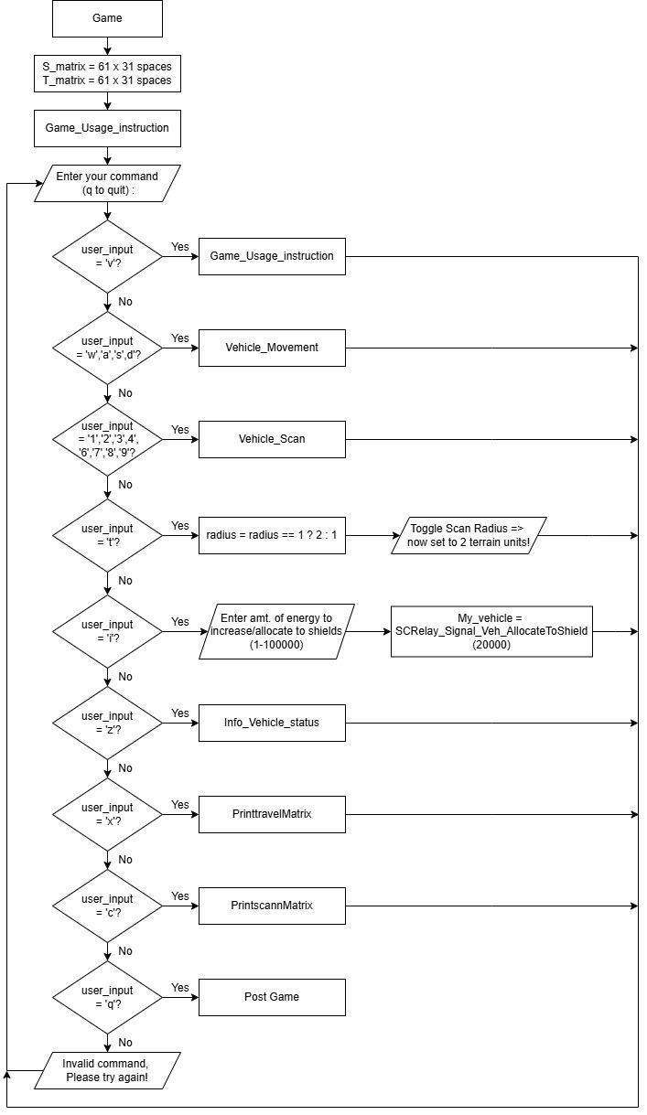

2.3.2 Game (Code)

Game
Declaring of variable | int radius = 1;  long energyToAllocate;
Description | Int radius variable is to initialized to 1 by default unless the user changes.  long energyToAllocate is used to store user input of how much they want to allocate energy to shield.
Main Function | void Game()  {  int radius = 1;  long energyToAllocate;  for (int i = 0; i < ROWS; i++)  {  for (int j = 0; j < COLS; j++)  {  S_matrix[i][j] = ' ';  }  }  for (int i = 0; i < ROWS; i++)  {  for (int j = 0; j < COLS; j++)  {  T_matrix[i][j] = ' ';  }  }  Game_Usage_instruction();  do  {  printf("Enter your command (q to quit) : ");  char_checker();  printf("\n");  if (Error == 0)  {  switch(user_input_c)  {  case 'q':  break;  case 'v':  Game_Usage_instruction();  break;  case 'w':  case 'a':  case 's':  case 'd':  Vehicle_Movement();  break;  case '1':  case '2':  case '3':  case '4':  case '6':  case '7':  case '8':  case '9':  Vehicle_Scan(radius);  Break;  case 't':  radius = (radius == 1) ? 2 : 1;  printf("Toggle Scan Radius => now set to %d terrain units! \n",radius);  break;  case 'i':  printf("Enter amt. of energy to increase / allocate to shields (1 - 100000) : ");  scanf(" %ld",&energyToAllocate);// Enter amount of energy to allocate  while (getchar() != '\n');  My_vehicle = SCRelay_Signal_Veh_AllocateToShield(energyToAllocate);  printf("\n");  Break;  case 'z':  printf("Vehicle Status / Statistics : \n\n");  Info_vehicle_status();  break;  case 'x':  printf("Currently Explored Terrain Layout : \n");  printtravelMatrix(T_matrix, midRow, midCol);  break;  case 'c':  printscanMatrix(S_matrix, midRow, midCol);  break;  default:  printf("Invalid Command : '%c', please try again!\n",user_input_c);  Break;  }  }  printf("\n");  }  while(user_input_c != 'q');  }
Description | The main function starts by initializing radius & energyToAllocate followed by matrices responsible for scan and movement.  It then calls the Game_User_instruction(); to display the menu.  Afterwards, there will be a do while loop which will continuously run unless user input is q.  Inside the do while loop, it will execute printf("Enter your command (q to quit) : "); to tell the user to enter an input, afterward the function char_checker(); is responsible for getting the user input and set a global variable Error to either 0 or 1.  Afterwards, an if statement will be executed if the global variable Error is set to 0.  Assuming that the user enters a valid input and passes the char_checker(); function, the switch statement inside the if statement will check the global variable user_input_c.  User input ‘q’ will instantly get out of the switch and since the do while loop condition only runs when input is not q, the do while loop will stop running and quit the game. If not the while loop will just continue and ask the user to enter their next input.  User input ‘v’ will call the Game_Usage_instruction(); function which prints the game instruction. Which then gets out of the switch statement and asks the user to enter their input.  If the user were to input w,a,s it will drop instantly to case ‘d’ as they are all movement input. So then it will call the Vehicle_Movement(); function and move the vehicle to direction based on user input.  If the user were to input 1,2,3,4,5,6,7,8 it would drop instantly to case ‘9’ which then calls the Vehicle_Scan(radius); function and scans the direction based on the user input.  User input ‘t’ will change the scan radius between 1 and 2.  It is done by radius = (radius == 1) ? 2 : 1; It checks if radius is 1 “(radius == 1)” , if it is true, then radius will be set to 2, if it is not 1 radius will be set to 1. After that, it will tell the user the new scan radius value by executing “printf("Toggle Scan Radius => now set to %d terrain units! \n",radius);” afterwards, it will exit the switch.  User input ‘i’ will first execute “printf("Enter amt. of energy to increase / allocate to shields (1 - 100000) : ");”, To tell user to input how much energy they want to locate between 1-10000. Afterwards, “scanf(" %ld",&energyToAllocate);” will get the user’s desired input and store it inside the variable “energyToAllocate”. Afterwards, a while loop will be executed to remove empty spaces. Afterwards, SCRelay_Signal_Veh_AllocateToShield(energyToAllocate); is called to send out energy to allocate to the header file and gets output.  User input ‘z’ will first execute “printf("Vehicle Status / Statistics : \n\n");” then calls Info_vehicle_status(); function to print the status of the function.  User input ‘x’ will first execute “printf("Currently Explored Terrain Layout : \n");” then calls the printtravelMatrix(T_matrix, midRow, midCol); function with 3 input parameters, T_matrix, midRow & midCol.  User input ‘c’ will first execute “printf("Currently Scanned Terrain Layout : \n");” then calls the printscanMatrix(S_matrix, midRow, midCol); function with 3 input parameters, S_matrix, midRow & midCol.  If any of the above cases does not match, the default case will be executed and print “Invalid Command : '%c', please try again!”,user_input_c
Sub  Function  Vehicle_Movement(); | void Vehicle_Movement()  {  movement++;  before_energy = My_vehicle.totEnergyUsed;  before_shield = My_vehicle.totShieldEnergyUsed;  switch(user_input_c)  {  case 'w':  scanresult = SCRelay_Signal_Veh_ScanNorth(&My_vehicle_Dup);  if (scanresult != '?' && scanresult != '#')  {  T_matrix[midRow-1][midCol] = scanresult;  midRow -= 1;  printf("Move Up\n");  }  My_vehicle = SCRelay_Signal_Veh_MoveUpNorth();  break;  case 'a':  scanresult = SCRelay_Signal_Veh_ScanWest(&My_vehicle_Dup);  if (scanresult != '?' && scanresult != '#')  {  T_matrix[midRow][midCol-1] = scanresult;  midCol -= 1;  printf("Move Left");  }  My_vehicle = SCRelay_Signal_Veh_MoveLeftWest();  break;  case 's':  scanresult = SCRelay_Signal_Veh_ScanSouth(&My_vehicle_Dup);  if (scanresult != '?' && scanresult != '#')  {  T_matrix[midRow+1][midCol] = scanresult;  midRow += 1;  printf("Move Down");  }  My_vehicle = SCRelay_Signal_Veh_MoveDownSouth();  break;  case 'd':  scanresult = SCRelay_Signal_Veh_ScanEast(&My_vehicle_Dup);  if (scanresult != '?' && scanresult != '#')  {  T_matrix[midRow][midCol+1] = scanresult;  midCol += 1;  printf("Move Right");  }  My_vehicle = SCRelay_Signal_Veh_MoveRightEast();  break;  }  if(scanresult == ' ')  {  T_matrix[midRow][midCol] = '_';  }  T_counter(T_terrain,  sizeof(T_terrain) / sizeof(T_terrain[0]),  scanresult,  My_vehicle.totEnergyUsed - before_energy,  My_vehicle.totShieldEnergyUsed - before_shield);  Info_vehicle_status();  printtravelMatrix(T_matrix, midRow, midCol);  }
Description of sub function | This sub function is responsible for vehicle movement, it is called in the main function. At the start it would do an increment of the movement variable to keep track of the number of times the vehicle has moved. After that it gets the current state of energy and shield then a switch case that takes in user input is executed.  If the user were to type in ‘w’, SCRelay_Signal_Veh_ScanNorth will be called and it would return a char which is then stored in the scanresult variable. After that an if statement will check to make sure that scanresult must not equal to ‘?’ and ‘#’, if the condition is met then at the variable T_matrix will be updated, by midRow-1 which targets the row above while the midCol variable remains unchanged, after that, that particular element of the matrix is being updated with the return value that was stored in scanresult. After that it will update midRow variable by deducting 1 from the current midRow variable.Followed by printing “Move Up”. After that the SCRelay_Signal_Veh_MoveUpNorth(); will be called to move up by 1 position, finally it a break sentence is executed to get out of the switch statement.  If the user were to type in ‘a’, SCRelay_Signal_Veh_ScanWest will be called and it would return a char which is then stored in the scanresult variable. After that an if statement will check to make sure that scanresult must not equal to ‘?’ and ‘#’, if the condition is met then at the variable T_matrix will be updated, by midCol-1 which targets the column on the left side while the midRow variable remains unchanged, after that, that particular element of the matrix is being updated with the return value that was stored in scanresult. After that it will update the midCol by deducting 1 from the current midCol variable.Followed by printing “Move Left”. After that the SCRelay_Signal_Veh_MoveLeftWest(); will be called to move up by 1 position, finally a break sentence is executed to get out of the switch statement.  If the user were to type in ‘s’, SCRelay_Signal_Veh_ScanSouth will be called and it would return a char which is then stored in the scanresult variable. After that an if statement will check to make sure that scanresult must not equal to ‘?’ and ‘#’, if the condition is met then at the variable T_matrix will be updated, by midRow+1 which targets the column below while the midRow variable remains unchanged, after that, that particular element of the matrix is being updated with the return value that was stored in scanresult. After that it will update the midCol value by adding 1 to the current midCol variable.Followed by printing “Move Down”. After that the SCRelay_Signal_Veh_MoveDownSouth(); will be called to move down by 1 position, finally a break sentence is executed to get out of the switch statement.  If the user were to type in ‘d’, SCRelay_Signal_Veh_ScanEast will be called and it would return a char which is then stored in the scanresult variable. After that an if statement will check to make sure that scanresult must not equal to ‘?’ and ‘#’, if the condition is met then at the variable T_matrix will be updated, by midCol+1 which targets the column on the right side while the midRow variable remains unchanged, after that, that particular element of the matrix is being updated with the return value that was stored in scanresult. After that it will update the midCol by adding 1 to the current midCol variable.Followed by printing “Move Right”. After that the SCRelay_Signal_Veh_MoveRightEast(); will be called to move right by 1 position, finally a break sentence is executed to get out of the switch statement.  After going through the switch cases, and if the scanresult happens to be a whitespace, that particular matrix coord that was scanned will be placed with ‘_’.  Afterward a function T_counter which takes in 6 parameters will be called to updating the current position.
Sub  Function  Vehicle_Scan(); | void Vehicle_Scan(int radius)  {  scanned++;  before_energy = My_vehicle.totEnergyUsed;  if(radius == 1)  {  switch (user_input_c)  {  case '1':  scanresult = SCRelay_Signal_Veh_ScanSouthWest(&My_vehicle);  S_matrix[midRow+1][midCol-1] = scanresult;  printf("SW 1 \n");  break;  case '2':  scanresult = SCRelay_Signal_Veh_ScanSouth(&My_vehicle);  S_matrix[midRow+1][midCol] = scanresult;  printf("S 1 \n");  break;  case '3':  scanresult = SCRelay_Signal_Veh_ScanSouthEast(&My_vehicle);  S_matrix[midRow+1][midCol+1] = scanresult;  printf("SE 1 \n");  break;  case '4':  scanresult = SCRelay_Signal_Veh_ScanWest(&My_vehicle);  S_matrix[midRow][midCol-1] = scanresult;  printf("W 1 \n");  break;  case '6':  scanresult = SCRelay_Signal_Veh_ScanEast(&My_vehicle);  S_matrix[midRow][midCol+1] = scanresult;  printf("E 1 \n");  break;  case '7':  scanresult = SCRelay_Signal_Veh_ScanNorthWest(&My_vehicle);  S_matrix[midRow-1][midCol-1] = scanresult;  printf("NW 1 \n");  break;  case '8':  scanresult = SCRelay_Signal_Veh_ScanNorth(&My_vehicle);  S_matrix[midRow-1][midCol] = scanresult;  printf("N 1 \n");  break;  case '9':  scanresult = SCRelay_Signal_Veh_ScanNorthEast(&My_vehicle);  S_matrix[midRow-1][midCol+1] = scanresult;  printf("NE 1 \n");  break;  }  Scanned_Update(S_1_terrain, sizeof(S_1_terrain) / sizeof(S_1_terrain[0]), scanresult);  }  else if (radius == 2)  {  switch (user_input_c)  {  case '1':  scanresult = SCRelay_Signal_Veh_ScanSouthWest2(&My_vehicle);  S_matrix[midRow+2][midCol-2] = scanresult;  printf("SW 2 \n");  break;  case '2':  scanresult = SCRelay_Signal_Veh_ScanSouth2(&My_vehicle);  S_matrix[midRow+2][midCol] = scanresult;  printf("S 2 \n");  break;  case '3':  scanresult = SCRelay_Signal_Veh_ScanSouthEast2(&My_vehicle);  S_matrix[midRow+2][midCol+2] = scanresult;  printf("SE 2 \n");  break;  case '4':  scanresult = SCRelay_Signal_Veh_ScanWest2(&My_vehicle);  S_matrix[midRow][midCol-2] = scanresult;  printf("W 2 \n");  break;  case '6':  scanresult = SCRelay_Signal_Veh_ScanEast2(&My_vehicle);  S_matrix[midRow][midCol+2] = scanresult;  printf("E 2 \n");  break;  case '7':  scanresult = SCRelay_Signal_Veh_ScanNorthWest2(&My_vehicle);  S_matrix[midRow-2][midCol-2] = scanresult;  printf("NW 2 \n");  break;  case '8':  scanresult = SCRelay_Signal_Veh_ScanNorth2(&My_vehicle);  S_matrix[midRow-2][midCol] = scanresult;  printf("N 2 \n");  break;  case '9':  scanresult = SCRelay_Signal_Veh_ScanNorthEast2(&My_vehicle);  S_matrix[midRow-2][midCol+2] = scanresult;  printf("NE 2 \n");  break;  }  Scanned_Update(S_2_terrain, sizeof(S_2_terrain) / sizeof(S_2_terrain[0]), scanresult);  }  printf("Returned (scanned) terrain symbol is '%c'. Energy used '%ld'. \n\n", scanresult, My_vehicle.totEnergyUsed - before_energy);  Info_vehicle_status();  printscanMatrix(S_matrix, midRow, midCol);  }
Description | This sub function is responsible for vehicle scanning, it is called in the main function. At the start it would do an increment of the scanned variable to keep track of the number of times the vehicle has scanned. After that it gets the current state of energy store it in the variable before_energy. Afterwards, an if statement is executed that takes validates the input parameter of this subfunction, “radius”. If radius == 1 then a series of switch statement would be executed with condition that validates the user input variable, user_input_c.  If user input is 1, then SCRelay_Signal_Veh_ScanSouthWest would be called and the return value from it would be stored in scanresult. Afterwards, it is stored in the S_matrix which targets the bottom left cell, when midRow+1, it would target the cell below afterwards, midCol - 1 would target the cell on the left thus bottom left.  Afterwards, it would print “SW 1” then a break is executed to get out of the switch statement.  If user input is 2, then SCRelay_Signal_Veh_ScanSouth would be called and the return value from it would be stored in scanresult. Afterwards, it is stored in the S_matrix which targets the bottom cell, while midRow+1, it would target the cell below afterwards midCol remains unchanged thus bottom cell.  Afterwards, it would print “S 1” then a break is executed to get out of the switch statement.  If user input is 3, then SCRelay_Signal_Veh_ScanSouthEast would be called and the return value from it would be stored in scanresult. Afterwards, it is stored in the S_matrix which targets the bottom right cell, when midRow+1, it would target the cell below afterwards, midCol + 1 would target the cell on the right thus bottom right.  Afterwards, it would print “SE 1” then a break is executed to get out of the switch statement.  If user input is 4, then SCRelay_Signal_Veh_ScanWest would be called and the return value from it would be stored in scanresult. Afterwards, it is stored in the S_matrix which targets the left cell, while midCol-1, it would target the cell on the left; afterwards midRow remains unchanged, thus the left cell.  Afterwards, it would print “W 1” then a break is executed to get out of the switch statement.  If user input is 6, then SCRelay_Signal_Veh_ScanEast would be called and the return value from it would be stored in scanresult. Afterwards, it is stored in the S_matrix which targets the right cell, while midCol+1, it would target the cell on the right; afterwards midRow remains unchanged, thus the right cell.  Afterwards, it would print “E 1” then a break is executed to get out of the switch statement.  If user input is 7, then SCRelay_Signal_Veh_ScanNorthWest would be called and the return value from it would be stored in scanresult. Afterwards, it is stored in the S_matrix which targets the top left cell, when midRow-1, it would target the cell above afterwards, midCol - 1 would target the cell on the left thus top left.  Afterwards, it would print “NW 1” then a break is executed to get out of the switch statement.  If user input is 8, then SCRelay_Signal_Veh_North would be called and the return value from it would be stored in scanresult. Afterwards, it is stored in the S_matrix which targets the top cell, while midRow-1, it would target the cell above; afterwards midCol remains unchanged, thus the top cell.  Afterwards, it would print “N 1” then a break is executed to get out of the switch statement.  If user input is 9, then SCRelay_Signal_Veh_ScanNorthEast would be called and the return value from it would be stored in scanresult. Afterwards, it is stored in the S_matrix which targets the top right cell, when midRow-1, it would target the cell above afterwards, midCol + 1 would target the cell on the right thus top left.  Afterwards, it would print “NE 1” then a break is executed to get out of the switch statement.  After the switch statement is executed, the function Scanned_Update(S_1_terrain, sizeof(S_1_terrain) / sizeof(S_1_terrain[0]), scanresult); is called to update the result of the scan.  The else if statement does the same just that it scans further so the midRow and midCol would +2.  After finish executing the if statement, the program would print the symbol of the scanned terrain and the energy used. Then the Info_vehicle_status(); called to show the current vehicle status then the printscanMatrix(S_matrix, midRow, midCol); is called to show the scanned map, which takes in the latest values of the midRow, midCol and S_matrix.
Sub Function  Info_vehicle_status(); | void Info_vehicle_status()  {  printf("Initial Enrg : %1ld, Tot Enrg Use : %1ld, Tot Shld Enrg Use : % 1ld, Engy Left : %1ld, Shld Enrg Left : %1ld \n\n", My_vehicle.initialEnergy, My_vehicle.totEnergyUsed, My_vehicle.totShieldEnergyUsed, My_vehicle.currEnergy, My_vehicle.currShieldEnergy);  }
Description | The function Info_vehicle_status(); prints out the information tied to the vehicle’s energy levels. When called, the function will print out the energy levels in order of:  Initial Energy, Total Energy Used, Total Shield Energy Used, Current Energy Left, Current Shield Energy Left
Sub Function  printtravelMatrix(); | void printtravelMatrix()  {  for (int i = 0; i < ROWS; i++)  {  for (int j = 0; j < COLS; j++)  {  if (i == midRow && j == midCol)  {  printf("\033[4m"); // Start underlining  }  char currentChar = T_matrix[i][j];  switch (currentChar)  {  case 'X':  printf("\033[31m%c\033[0m", currentChar); // Red  break;  case 'M':  printf("\033[35m%c\033[0m", currentChar); // Purple  break;  case 'h':  case 'f':  case 'j':  printf("\033[32m%c\033[0m", currentChar); // Green  break;  case 'w':  printf("\033[33m%c\033[0m", currentChar); // yellow  break;  case '~':  printf("\033[36m%c\33[0m", currentChar); // cyan  break;  case 'E':  printf("\033[37m%c\33[0m", currentChar); // white  break;  case '_':  printf("\033[47;37m%c\33[0m", currentChar); // White background with white word  break;  default:  printf("%c", currentChar); // Default formatting for other characters  break;  }  if (i == midRow && j == midCol)  {  printf("\033[0m "); // Stop underlining and reset formatting  }  else  {  printf(" "); // Ensure spacing is consistent  }  }  printf("\n");  }  }
Description | The function printtravelMatrix(), will print the areas that the vehicle has travelled when called. When the function is called, it will start by executing the outer for loop which is responsible for tracking the rows, while the inner for loop is responsible for the columns.  Inside the inner for loop, the 1st switch statement is responsible for checking the center cell of the matrix, if it is the center cell it will underline the character. After that a char variable currentChar will store whatever is inside the current matrix cell by taking from the variable T_matrix[i][j]. Example, if say inside  i = 0, j = 0 contains char data E, then the char data will be stored inside the currentChar variable, after which a switch statement, switch(currentChar) will evaluate the data in currentChar following these conditions.  If it contains an X, it will paint the char red  If it contains an M, it will paint the char purple  If it contains h,f or j, it will paint the char green  If it contains an w, it will paint the char yellow  If it contains an ~, it will paint the char cyan  If it contains an E, it will paint the char white  If it contains an ‘-’, it will first check if the char is at center of the matrix, if it is not then it will be a whitebackground with whiteword.  For all other char will be default formatting.  After the switch statement is executed, an if statement will check if it is currently at the center of the matrix, if it is true then it will Stop underlining and reset the formatting, else, it will print “ “ to ensure spacing is consistent. After the inner loop for that row, it will print \n to go to the next row and the process repeats itself.
Sub  Function  printscanMatrix(); | void printscanMatrix()  {  printf("Currently Scanned Terrain Layout : \n");  for (int i = 0; i < ROWS; i++)  {  for (int j = 0; j < COLS; j++)  {  if (i == midRow && j == midCol)  {  printf("\033[4m"); // Start underlining  }  char currentChar = S_matrix[i][j];  switch (currentChar)  {  case '#':  case 'X':  printf("\033[31m%c\033[0m", currentChar); // Red  break;  case '-':  printf("\033[34m%c\033[0m", currentChar); // Blue  break;  case 'M':  printf("\033[35m%c\033[0m", currentChar); // Purple  break;  case 'E':  printf("\033[37m%c\033[0m", currentChar); // White  break;  case 'h':  case 'f':  printf("\033[32m%c\033[0m", currentChar); // Green  break;  case 'w':  printf("\033[33m%c\033[0m", currentChar); // yellow  break;  case '~':  printf("\033[36m%c\33[0m", currentChar); // Cyan  break;  default:  printf("%c", currentChar); // Default formatting for other characters  break;  }  if (i == midRow && j == midCol)  {  printf("\033[0m "); // Stop underlining and reset formatting  }  else  {  printf(" "); // Ensure spacing is consistent  }  }  printf("\n");  }  }
Description | The function printtravlMatrix(), will print the places that the vehicle have travelled when called. When called, it will start by executing the outer for loop which is responsible for tracking the rows, while the inner for loop is responsible for the column. Inside the inner loop, the 1st switch statement is responsible for checking the center cell of the matrix, if it is the center cell it will underline the character. After that a char variable currentchar will store whatever is inside the current matrix cell by taking from the variable T_matrix[i][j], if lets say inside  i = 0, j = 0 contains E, then it will be stored inside currentchar variable, after which a switch statement will evaluate the variable currentChar.  If it contains an X, it will paint the char red  If it contains an M, it will paint the char purple  If it contains h,f or j, it will paint the char green  If it contains an w, it will paint the char yellow  If it contains an ~, it will paint the char cyan  If it contains an E, it will paint the char white  If it contains an ‘-’, it will first check if the char is at center of the matrix, if it is not then it will be a whitebackground with whiteword.  For all other char will be default formatting.  After the switch statement is executed, an if statement will check if it is currently at the center of the matrix, if it is true then it will Stop underlining and rest formatting if not, it will print “ “ to ensure spacing is consistent. After the inner loop for that row, it will print \n to go to the next row and the process repeats.

2.4 Post Game

2.4.1 Post Game (Flow Chart)
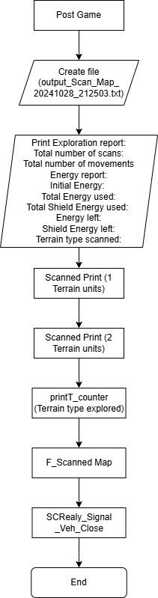

2.4.2 Post Game (Code)

Post Game
Declaring of variables | char filename[100];  time_t now = time(NULL);  struct tm *t = localtime(&now);
Description | Filename[100], declare array with 100 characters  time(NULL), returns current calendar time, Ex. 2024102  localtime(&now), returns current time, Ex. 212503.
Main Function | strftime(filename, sizeof(filename), "./logs/output_Scan_Map_%Y%m%d_%H%M%S.txt", t);  file = fopen(filename, "w");  if (file == NULL)  {  printf("Error opening file!\n");  }  printf("---------------------------------- \n");  printf("--- Team 1 Exploration Report! --- \n");  printf("---------------------------------- \n\n\n");  printf("Total no. of scans taken: %d \n", scanned);  printf("Total no. of movements (steps) taken: %d \n\n",movement);  printf("[Energy Report] \n\n");  printf("Initial Energy : % 1ld \n", My_vehicle.initialEnergy);  printf("Total Energy Used : % 1ld \n", My_vehicle.totEnergyUsed);  printf("Total Shield Energy Used : % 1ld \n", My_vehicle.totShieldEnergyUsed);  printf("Energy Left : % 1ld \n", My_vehicle.currEnergy);  printf("Shield Energy Left : % 1ld \n\n", My_vehicle.currShieldEnergy);  printf("[Terrain type Scanned] \n\n");  Scanned_Print(S_1_terrain, sizeof(S_1_terrain) / sizeof(S_1_terrain[0]), "[1 terrain units]");  printf("\n");  Scanned_Print(S_2_terrain, sizeof(S_2_terrain) / sizeof(S_2_terrain[0]), "[2 terrain units]");  printf("\n");  printT_counter(T_terrain, sizeof(T_terrain) / sizeof(T_terrain[0]), "[Terrain type Explored]");  F_Scanned_Map();  SCRelay_Signal_Veh_Close ();
Description | sfttime(filename, sizeof(filename), filename is the destination of the files will be stored  t is a pointer to current date and time  fopen(filename,”w”), is open filename and make it a write mode so to write data  If (file == NULL) is to check if a file exists in the directory.

Post Game
Sub Function | void Scanned_Print(const Scanned_Counter counters[], int size, const char *setName)  {  printf("%s \n", setName);  for (int i = 0; i < size; i++)  {  printf("Type '%c' : %d \n", counters[i].character, counters[i].count);  }  }
Description | Const Scanned_Counter counters, is an array point to S_1_terrain  Int size, is point to sizeof(S_1_terrain)/sizeof(S_1_terrain[0]), is to calculate number of array in S_1_terrain  for (int i = 0; i < size; i++), is to repeat number of times inside array
Sub Function | void printT_counter(const CharCounter2 counters[], int size, const char *setName)  {  printf("%s:\n", setName);  for (int i = 0; i < size; i++) {  printf("Type '%c' : %d time, %d energy, %d shield energy. \n",  counters[i].character, counters[i].count, counters[i].energy, counters[i].shield);  }  }
Description | const CharCounter2 counters[], is an array point to T_terrain  Int size, is point to sizeof(T_terrain)/sizeof(T_terrain[0]), is to calculate number of array in T_terrain  for (int i = 0; i < size; i++), is to repeat number of times inside array

Post Game
Sub Function | void F_Scanned_Map()  {  fprintf(file, "Currently Scanned Terrain Layout : \n");  for (int i = 0; i < ROWS; i++)  {  for (int j = 0; j < COLS; j++)  {  char currentChar = S_matrix[i][j];  if (i == midRow && j == midCol)  {  fprintf(file, "_ ");  }  else  {  fprintf(file, "%c ", currentChar);  }  }  fprintf(file, "\n");  }  }
Description | fprinf, print out string to file  Print out every character into file from S_matrix[i][j]

3.0 Testing and Discovery

3.1 Terrain symbols
Based on the current scenario, these are the terrain symbols as shown below.

Terrain types
"#" | " " | "j" | "M" | "~" | "X"
"S" | "E" | "?" | "f" | "h" | "w"

3.2 Energy and shield energy when moving
Based on testing of every terrain when movement, these are the energy and shield energy as shown below.
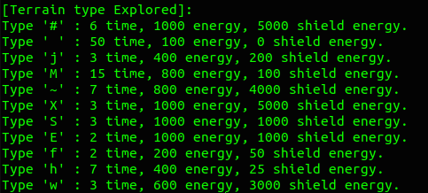

3.3 Scan energy expenditure
Based on the current position ‘_’, if the user scans 1 unit radius North, South, East, or West, it takes up 90 energy. If the user scans 1 unit radius around the corner, North-East, East-West, South-West, and North-West, it takes up 360 energy. If the user scans 2 units of radius, the energy takes up twice as much as 1 unit of radius, as shown below.

Scan Energy
720 |  | 180 |  | 720
 | 360 | 90 | 360
180 | 90 | _ | 90 | 180
 | 360 | 90 | 360
720 |  | 180 |  | 720

4.0 Reflections on program development

4.1 Work breakdown

4.2 Obstacle encountered

5.0 Extra functionalities

- From section B, Function Pre-game();. We program our code to check the scenario file is in the folder before continuing. With this step, users need not enter until mission type to know that the file does not exist or they have typed wrongly. If the file could not be found, the user is to retype the scenario file again until the scenario file is found.

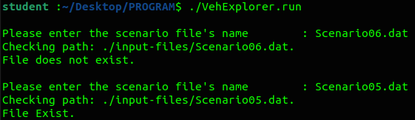

- From section B, Function of Post game, subfunction of T_counter(CharCounter2 counters[], int size, char input, int energyUsed, int shieldUsed). Instead of manually counting the energy and shield energy, we create a dictionary that, if the character is being scanned, automatically calculates the energy and shield energy and stores it to the character type. So for future use, the data can be read without running the program.

- From section B, function Post game, subsection function F_Scanned_Map();. We create an empty txt file to store the output of the scan map with a date and time. The reason we did this is that due to insufficient energy to scan the map, we ran the program twice and have 2 output files. From the 2 output files, we can combine them and generate a full map by using Excel.

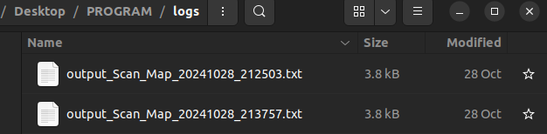
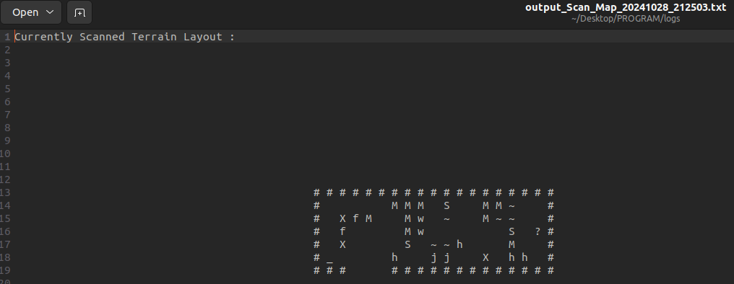
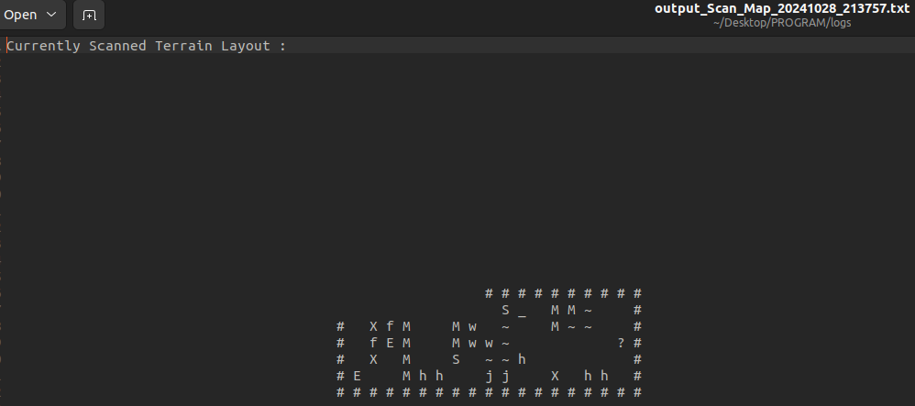

# | # | # | # | # | # | # | # | # | # | # | # | # | # | # | # | # | # | #
# |  |  |  |  |  | M | M | M |  | S |  |  | M | M | ~ |  |  | #
# |  | X | f | M |  |  | M | w |  | ~ |  |  | M | ~ | ~ |  |  | #
# |  | f | E | M |  |  | M | w | w | ~ |  |  |  | M | S |  | ? | #
# |  | X |  | M |  |  | S |  | ~ | ~ | h |  |  |  | M |  |  | #
# | E |  |  | M | h | h |  |  | j | j |  |  | X |  | h | h |  | #
# | # | # | # | # | # | # | # | # | # | # | # | # | # | # | # | # | # | #

1.0 Architecture overview Beckham
2.0 System Design
Overflow Beckham
How to link header files Beckham

Pre- Game
Checking scenario file. Aloysius
Pre game program after scenario file Aloysius
How to send data to header file Aloysius
Char checker and int checker. James
Buffer overflow James
Game
Quit - ‘q’ Amos
Instruction - ‘v’ Amos
Info on vehicle - ‘z’ Amos
Energy to shield - ‘i’ Amos
Toggle - ‘t’ Lwin
Scanning ‘1’, ‘2’, 3’ ‘4’,’6’,’7’,’8’,9’ Lwin
Movement - ‘w’, ‘a’, ‘s’, ‘d’ Lwin
Scanned map - ‘x’ Kim
Traveled map - ‘c Kim
Post Game
Total number of scans Kim
Total number of movement Kim

3.0 Testing and discovery Leon

4.0 Reflection on program Leon

5.0 Extra functionalities Yong Jie

